**Practical No. 7A**

**To design and develop web pages using HTML Multimedia elements.**

Purva Kudre

2018BTECS00095

**Problem Statement 2:**

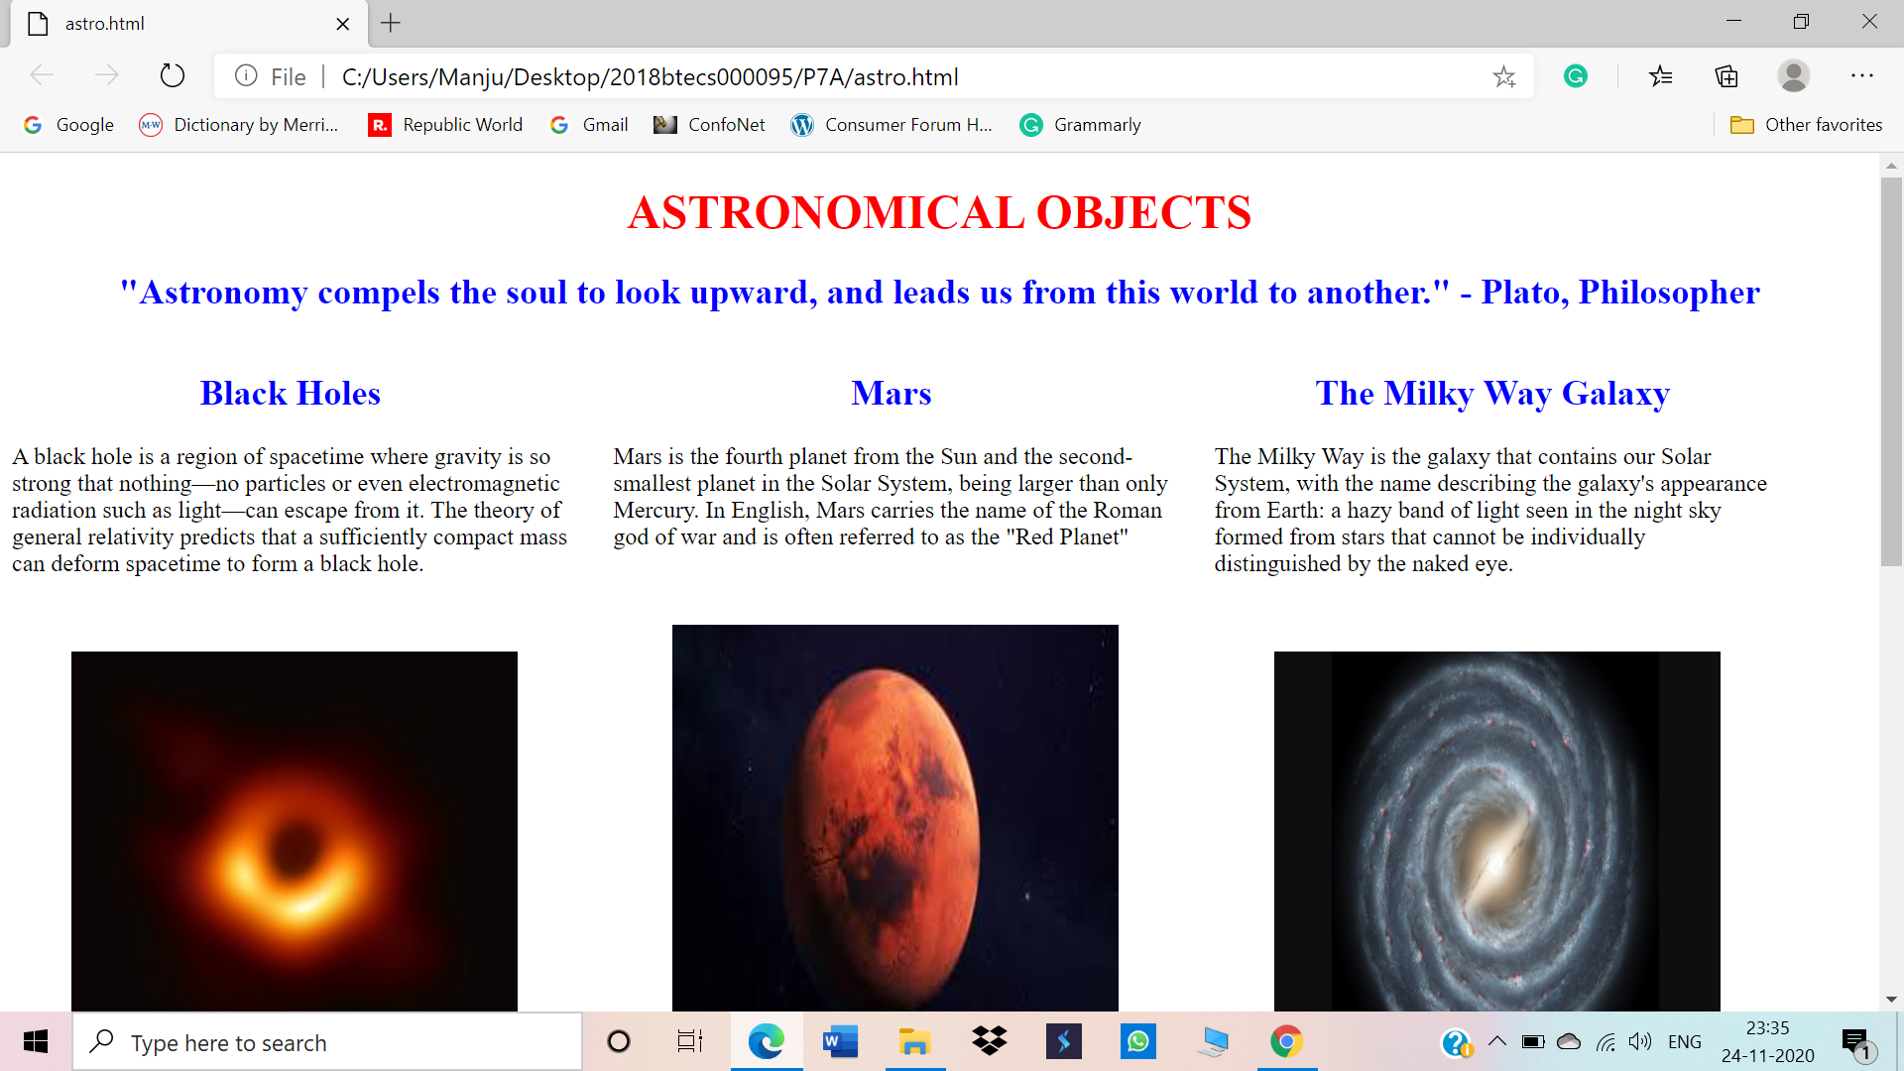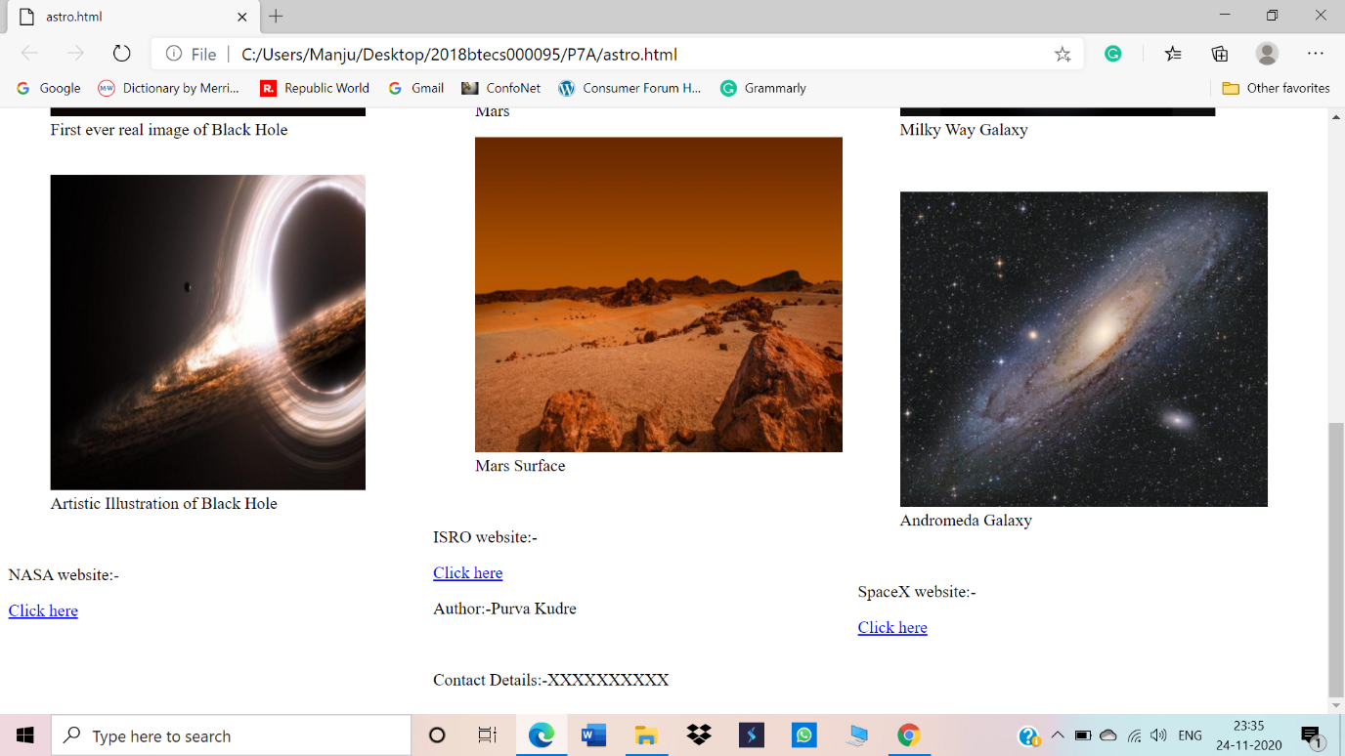

**Problem Statement 2:**

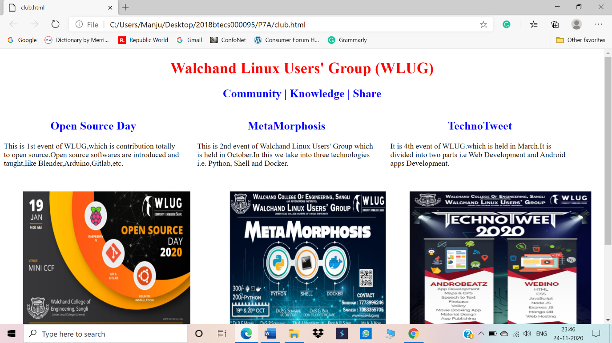

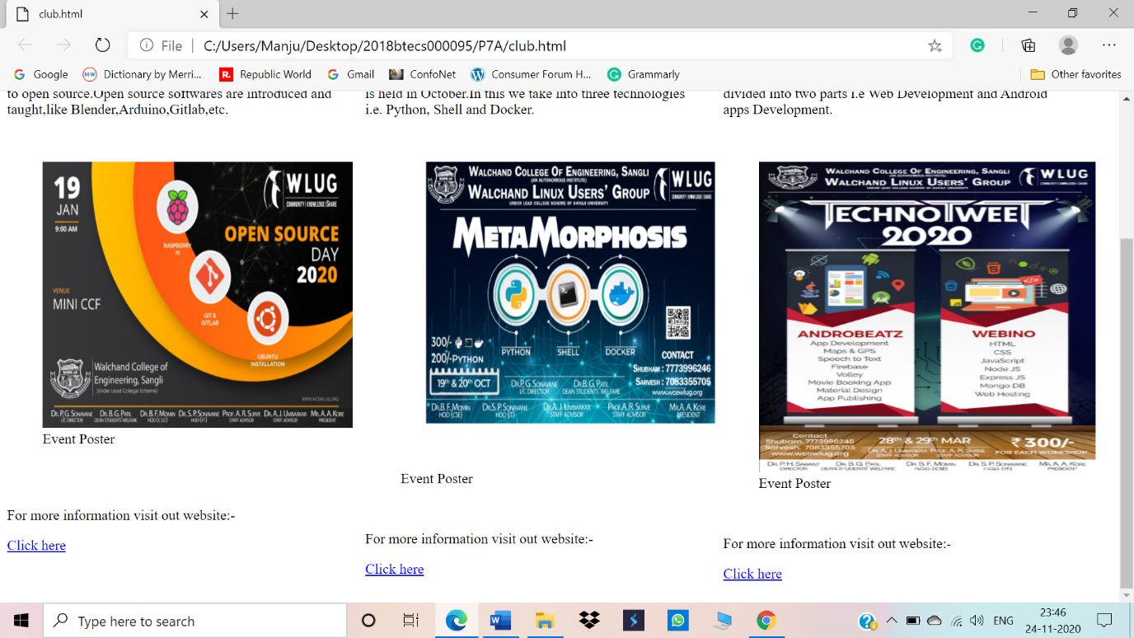

Github Link:-

https://github.com/Psk1999/2018btecs00095-7a